# **Logarithmic loss:**

Logarithmic loss measures the performance of a classification model where the prediction input is a probability value between 0 and 1. The goal of our machine learning models is to minimize this value. A perfect model would have a log loss of 0. Log loss increases as the predicted probability diverges from the actual label. So predicting a probability of .012 when the actual observation label is 1 would be bad and result in a high log loss.

Visualization:

The graph below shows the range of possible log loss values given a true observation (is Dog = 1). As the predicted probability approaches 1, log loss slowly decreases. As the predicted probability decreases, however, the log loss increases rapidly. Log loss penalizes both types of errors, but especially those predications that are confident and wrong!

[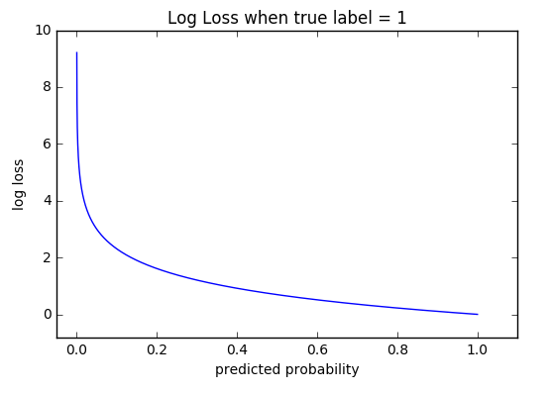](http://wiki.fast.ai/index.php/File:Log_loss_graph.png)

The equations below demonstrate how to calculate log loss for a single observation. When evaluating a model against a dataset, your log loss score is simply the average log loss across all observations.

### Variables

* N - number of observations
* M - number of possible class labels (dog, cat, fish)
* log - the natural logarithm
* y - a binary indicator (0 or 1) of whether class label c is the correct classification for observation o
* p - the model's predicted probability that observation o is of class c

### Binary Classification

In binary classification (M=2), the formula equals:

(*y* log ( *p* ) + ( 1 – *y* ) log ( 1 – *p* ) )

For example, given a class label of 1 and a predicted probability of .25, using the formula above we can calculate the log loss:

* (*1* log (0.25) + (1 – 1) log (1 – 0.25))
* (log (0.25) + 0 log (0.75))
* (log (0.25))

Similarly given a class label of 0 and a predicted probability of .25, we can calculate log loss as:

* *(0* log (.25) + (1 – 0) log (0 – .25))
* (1 log (-.25))
* (log (-0.25))

In multi-class classification (M>2), we take the sum of log loss values for each class prediction in the observation.

\sum is shorthand for summation or in our case the sum of all log loss values across classes

c=1 is the starting point in the summation (i.e. the first class)

Note:

Log Loss uses negative log to provide an easy metric for comparison. It takes this approach because the positive log of numbers < 1 returns negative values, which is confusing to work with when comparing the performance of two models.

[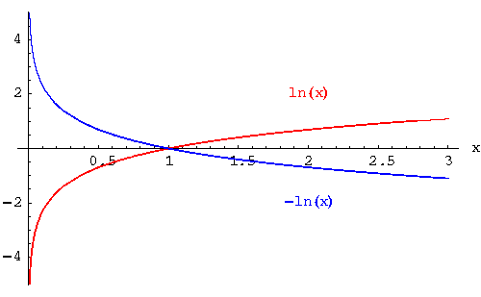](http://wiki.fast.ai/index.php/File:Log_vs_neglog.gif)